First Ginger Dispute Reference ID 10745049



Address Link ID = 81285354



@LinkResId @ResId

219264230 219264229

7 6

No results from [up_AddressLink_GatherResidenceDataAssets]

switched

DataAssetId DataAssetType

81285353 AdditionalAddressLink

81285359 AdditionalAddressLink

Outcome is would auto delete

Second Ginger Dispute Reference ID 10745050

Address Link ID = 81285353 - Would go to manual processing

@LinkResId @ResId

219264229 219264228

6 5

DataAssetId DataAssetType

81285354 AdditionalAddressLink

81285360 AdditionalAddressLink

Switched

DataAssetId DataAssetType

81285352 AdditionalAddressLink

81285358 AdditionalAddressLink

Outcome is would go to manual processing

Tests against all dispute links in Ginger Panel

Test 1 against third address link – 6 Prescott Street



Ginger Dispute reference number – 10745049

Numero Dispute Case ID – 5539

Numero Outcome - Address Link Removed (Auto)

Address Link ID – 81285354

Test 2 against second address link – 6 Prescott Street



Ginger Dispute reference number – 10745050

Numero Dispute Case ID – 5540

Numero Outcome -

Address Link ID - 81285353

Test 3 against first address link – 5 Prescott Street



Ginger Dispute reference number – 10753680

Numero Dispute Case ID – 5541

Numero Outcome -

Address Link ID - 81285352

Test 4 against first address link – 4 Prescott Street



Ginger Dispute reference number – 10753681

Numero Dispute Case ID – 5541

Numero Outcome -

Address Link ID - 81285352

Test 5 against second address link – 5 Prescott Street



Ginger Dispute reference number – 10753683

Numero Dispute Case ID – 5543

Numero Outcome -

Address Link ID - 81285353

Test 6 against third address link – 7 Prescott Street



Ginger Dispute reference number – 10753682

Numero Dispute Case ID – 5542

Numero Outcome -

Address Link ID - 81285354

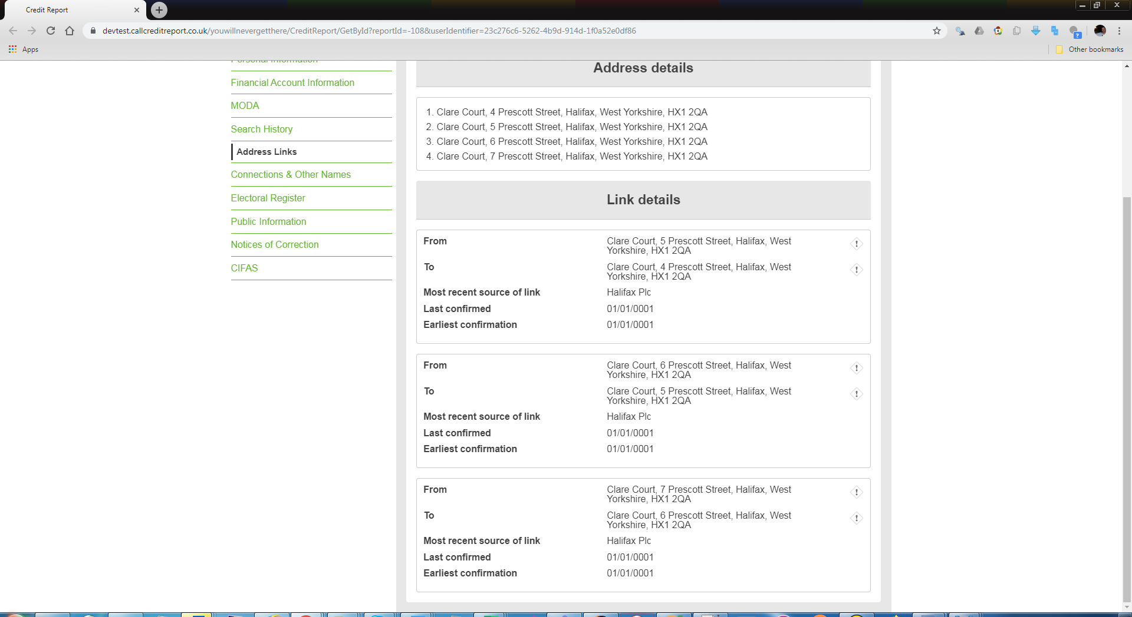



Below shows how the data was setup in the DB, illustrates the data origin and direct/implied address link configuration;

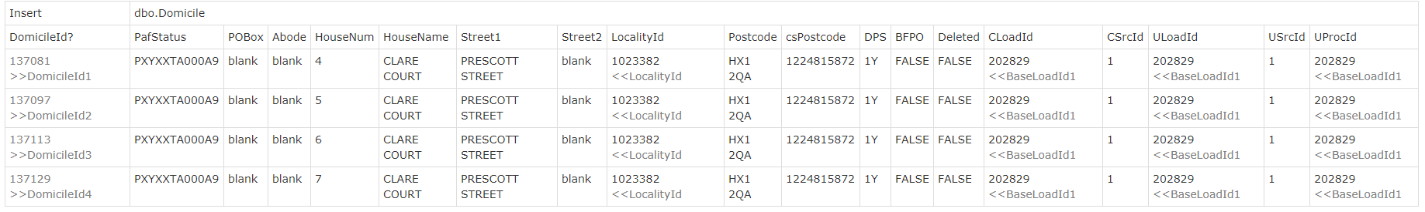

Note ResidenceId1 = DomicileId1, ResidenceId2 = DomicileId2 etc

